BALLARPUR INSTITUTE OF TECHNOLOGY

BALLARPUR – 442701



A Project Report on

“**RTO Complaint Portal**”

# DEPARTMENT OF UNDER-GRADUATE STUDIES IN

BACHELOR OF ENGINEERING

# COMPUTER SCIENCE AND ENGINEERING

Submitted by

**Mr. Pratik Gupta (PRN NO – 2041881242024)**

**Ms. Madhuri Waghare (PRN NO – 2041881242021)**

**Ms. Shubhangi Satghare (PRN NO – 2041881242037)**

**Ms. Sakshi Dhanorkar (PRN NO – 2041881242035)**

V Semester

Under the Guidance of

**Prof. Hirendra Hajare**

# (Department of Computer Science & Engineering)

DR. BABASAHEB AMBEDKAR TECHNOLOGICAL

UNIVERSITY, LONERE



Session 2022-23

BALLARPUR INSTITUTE OF TECHNOLOGY

BALLARPUR – 442701

DEPARTMENT OF COMPUTER SCIENCE AND ENGINEERING



CERTIFICATE

This is to certify that the project work on **“RTO Complaint Portal”** is a bonafied work carried out by **Mr. Pratik Gupta (PRN NO – 2041881242024), Ms. Madhuri Waghare (PRN NO – 2041881242021), Ms. Shubhangi Satghare (PRN NO – 2041881242037), Ms. Sakshi Dhanorkar (PRN NO - 2041881242034)** in partial fulfilment of the requirement for the award of degree of Bachelor of Engineering in the department of **Computer Science and Engineering**, offered by the **Dr. Babasaheb Ambedkar Technological University, Lonere**, during the academic year **2022-2023**. It is certified that all corrections/suggestions indicated have been incorporated in the report deposited in the departmental library. The report has been approved as it satisfies the academic requirements in respect of prescribed for the Bachelor of Engineering.

|  |  |  |  |
| --- | --- | --- | --- |
| Prof. Hirendra Hajare Prof. Deepali Khatwar | | | Prof. Hirendra Hajare |
| Guide | Mini project Coordinator |  | HoD |
| Dept. of CSE | Dept. of CSE |  | Dept. of CSE |
|  | Dr. Rajni Kant  Principal |  |  |
|  |  |  |  |
|  |  |  |  |
| Name of the Examiners | |  | Signature with Date |

1. ---------------------
2. ---------------------

**ACKNOWLEDGEMENT**

With immense pleasure and great respect I take this opportunity to express my deep sense of gratitude toward my guide, **Prof. Hirendra Hajare**, Professor and Head of Department of Computer Science and Engineering, B.I.T Ballarpur for invaluable guidance, inspiration, constant encouragement and motivation throughout the project work.

I am thankful to **Prof. Deepali Khatwar** Assistant Professor, Mini Project Co-ordinator Department of Computer Science and Engineering, B.I.T Ballarpur who helped me to understand basic methodologies of my project.

I am grateful to **Prof. Hirendra R. Hajare**, Head of Department, Department of Computer Science and Engineering, B.I.T Ballarpur and all the faculty of department Computer Science and Engineering, B.I.T, Ballarpur for providing the amicable environment and allowing me to use available facilities in this department during the course of this study.

We thank to **Dr. Rajni Kant** our beloved Principal, B.I.T Ballarpur for his encouragement and providing all facilities needed in our project.

I am very thankful to my friend and well-wisher who directly or indirectly helped me at every stage to complete this work.

Last but not least, I would like to thanks my family and almighty without their good wishes and blessing this dissertation work could not have been completed.

Mr. Pratik Gupta (PRN NO – 2041881242024)

Ms. Madhuri Waghare (PRN NO – 2041881242021)

Ms. Shubhangi Satghare (PRN NO – 2041881242037)

Ms. Sakshi Dhanorkar (PRN NO – 2041881242035)

**DECLARATION**

I hereby declare that

1. The work contained in this dissertation has been done by me under the supervision of my Guide.
2. The work has not been submitted to any other Institute for any degree or diploma.
3. I have followed the guidelines provided by the Institute in preparing the project report.
4. I have conformed to the norms and guidelines given in the Ethical Code of Conduct of the Institute.
5. Whenever I have used materials (data, theoretical analysis, figures, and text) from other sources, I have given due credit to them by citing them in the text of the report and giving their details in the references. Further, I have taken permission from the copyright owners of the sources, whenever it is necessary.

Mr. Pratik Gupta (PRN NO – 2041881242024)

Ms. Madhuri Waghare (PRN NO – 2041881242021)

Ms. Shubhangi Satghare (PRN NO – 2041881242037)

Ms. Sakshi Dhanorkar (PRN NO – 2041881242035)

**INDEX**

|  |  |  |
| --- | --- | --- |
| **Chapter no.** | **Topic** | **Page No.** |
|  | **Abstract** |  |
|  | **List of Figures** |  |
| **Chapter 1** | **Introduction** | **1** |
| **Chapter 2** | **Literature Review** | **4** |
| **Chapter 3** | **Proposed Work** | **6** |
| **Chapter 4** | **Research Methodology** | **11** |
| **Chapter 5** | **Project Design** | **13** |
| **Chapter 6** | **Result** | **20** |
| **Chapter 7** | **Hardware and Software Requirements** | **23** |
| **Chapter 8** | **Conclusion & Future Scope** | **24** |
| **Chapter 9** | **References** | **25** |

**ABSTRACT**

Existing process of RTO is very time consuming process. Now a days the young generations and many peoples are breaking the traffic rules and some of them also misbehaves with others. Some of the roads are also much damaged. It’s hard to make a complain of them. The RTO employees also have lots of work to be done and it is very hard to do many works at a same time and also some of them require a lot of paper works. And the person who wants to make a complain have to go to the RTO office or police station. As a result people cannot get the things done in right time, which waste the time and also energy. So to overcome with these drawbacks we are developing RTO complain portal which helps in complaining about any matter related to the RTO office any harsh driving etc. which is called RTO complain portal. The complain will be created in an online form. Such like that we will provide one type of environment which gives a user friendly means user can access and understand well and do what he or she wants means if any complain about the damaged road, harsh driving etc. then the user have to put some of their details for the information and proof if they had. In this way we develop a system which directly provides services like complaining about harsh driving, breaking traffic rules etc. administer is power user. He has the power to verify the data provided by the user, processing of data and providing appropriate solutions for their complain. If any person who has been authorized by the administrator. An authorized user should have a user name and password to access detailed information from the site excluding or accessing general information in shared, public pages.

**LIST OF FIGURES**

|  |  |  |
| --- | --- | --- |
| **SR.**  **NO** | **FIGURES** | **PAGE**  **NO** |
| **1** | **HTML Structure** | **13** |
| **2** | **CSS Structure** | **14** |
| **3** | **Architecture of MySQL** | **16** |
| **4** | **Combined working of MySQL and PHP** | **17** |
| **5** | **User Flow Chart** | **23** |
| **6** | **Admin Flow Chart** | **24** |
| **7** | **Admin Use Case** | **24** |

**INTRODUCTION**

# **Background**

In India we don’t have any direct communication between government and public in an efficient way for solving the problems i.e. for getting a problem solved in our place we have to bribe the officials and get them solved in 2-3 months which can be actually solved in 1 month of time.

In order to overcome this problem we can create an online web application .

Now-a-days ,the scenario has changed. In today’s world, more focus is given on the availability of the internet and thus using various applications and website present in the market Now days we are supposed to manage our daily work on time, accurately, very fast and with our satisfaction.

So we are using various technologies in our life for fulfillment of our daily work.   
The main purpose of the project is to help the public in knowing their place details and getting their problems solved in online without going to the office regularly until the problem is solved By this system the public can save their time.

Online Complaint Management System provides an online way of solving the problems faced by the public by saving time and eradicate corruption. The objective of the complaints management system is to make complaints easier to coordinate, monitor, track and resolve, and to provide company with an effective tool to identify and target problem areas, monitor complaints handling performance and make business improvements. Online Complaint Management is a management technique for assessing, analyzing and responding to customer complaints.

Complaints management software is used to record resolve and respond to customer complaints, requests as well as facilitate any other feedback.

implementation of this project involves usage of certain web technologies such as HTML5, CSS3 and Bootstrap4.

**1.2 Aim**

The idea of the project deals with the RTO complaint portal, which allows citizens to lodge a complaint against Road traffic violations.

The main purpose of the project is to help the public who are facing different problems in the localities by this online application. This project is having that potential to reduce the gap between people and Govt.

It can control unethical work of bribe and even it can reduce the processing time. In this project identification and solution for the complaints given by the people, rectifying them is the main concept of the project. A clear report is generated by the system which shows name, complaint type, etc.

All the above attributes help while viewing the report of complaints. The admin examines weather the problem is rectified or not within the grace period.

The main objective of this project is to make easy the process of complaint reporting with very simplified and effective way.

This project involves major problem solving modules where these acts as best solution for incoming bulk complaints.

**1.2.1 Objectives**

The objective of the complaints management system is to make complaints easier to coordinate, monitor, track and resolve, and to provide government with an effective tool to identify and target problem areas, monitor complaints handling performance and make area safe.

Online Complaint Management System provides an online way of solving the problems faced by the public by saving time and eradicate corruption. our main focus is to make this web application use full for the people and by using our website people can save their time to came office and complaint.

**The objective of the complaints management system is**

* To make complaints easier to coordinate, monitor,

track and resolve,

* To provide company with an effective tool to identify

and target problem areas, monitor complaints handling

performance

* To make business improvements.
* Prompt and specific retrieval of data.
* Flexibility in the system according to the changing

environment.

* Controlling redundancy in storing the same data

multiple times.

* Accuracy, timeliness and comprehensiveness of the

system output.

* Stability and operability by people of average

intelligence.

* Enhancement in the completion of work within the

constraints of time.

**1.3 Motivation**

**The main motivation of this project is that**

* The motivation for doing this project was primarily an interest in undertaking a challenging project in an interesting area of research
* With the help of this website we can make common peoples life easy .
* Every student should be do something different tried to make something new and that’s what we tried to do different.
* A municipal corporation is a type of local government in India that administers urban areas with a population of more than one million
* A type of local governing body that could provide services such as healthcare, education, housing and transport by collecting property taxes and administering grants from the state government

**1.4 Purposed work**

Online Complaint Management System provides an online way of solving the problems faced by the public by saving time and eradicate corruption , And The ability of providing many of the reports on the system , and add to Facilitate the process of submitting a complaint.

Our system has been implemented by the idea of the existing models and in addition to that, we have introduced a system . In this system the problem has been identify and rectify them with some grace period. The admin examines weather the problem is rectified or not within the grace period. This project resolves bulk complaints .the person who complaints their problem has a sufficient facility to explain through online instead of visiting the office and complaining through papers, without any further information about their complaints , they doesn’t knows any acknowledgment for their complaints weather it reaches the admin or not by this system the people who complaints through online can receive an acknowledgment about the registration of the complaint received to the database.

**LITERATURE REVIEW**

* 1. **Literature survey**

According to this system it saves time of people by directly launching complaint with the help of proposed system. They need not go to the government office for launching the complaints. People can get their problems/issues solved by directly posting it to the proposed system. People can post their suggestions. The proposed system contains the following facilities over the present system

Our system has been implemented by the idea of the existing models and in addition to that, we have introduced a system . In this system the problem has been identify and rectify them with some grace period. The admin examines weather the problem is rectified or not within the grace period. This project resolves bulk complaints .the person who complaints their problem has a sufficient facility to explain through online instead of visiting the office and complaining through papers, without any further information about their complaints , they doesn’t knows any acknowledgment for their complaints weather it reaches the admin or not by this system the people who complaints through online can receive an acknowledgment about the registration of the complaint received to the database. The main advantage of the system is the people can attach a image file into their complaint to revel the actual occurrence of their area or a place be recovered.

* The RTO complaint portal addresses the issue of local complaints in the context of Customer Relationship Management (CRM).
* The development of a new intelligent CRM framework, which integrates in a single approach different innovative analytical methods.
* Unlike conventional approaches, this new methodology can handle user complaints with respect to different variables, thus allowing organizations to find their user and complaints, and to address and provide solutions for their major complaints, hence promoting awareness.
* The RTO complaint portal also describes the successful application of the method to a real-world case: the virtually immeasurable number of complaints from users such as truck driver.

**2.2 Concluding Remarks**

After going through many research papers, articles and website to study more about the web design aspects. Geegs for Geeks, W3Schools, get Bootstrap are the three major website that we have referred. We have prior some knowledge of HTML, CSS and JavaScript but we were unknown about PHP and SQL. We have gone through step-wise lessons from W3Schools for learning SQL.

In recent there were no such specific website for the Indian Public for getting their complaint post online. We had seen many websites related for online complaint and tried to make our website look and work as effectively as possible. Thus making a website was try-and-error process.

**PROPOSED WORK**

**3.1 Proposed Method for Development:**

The website will be developed using PERN stack which consists of developing the front end using basic technologies such as HTML, CSS, and JavaScript. Along with this in order to provide a smooth user experience the project also uses jQuery and Ajaxfor performing asynchronous database operation.

The project is backed by Node framework which is a runtime environment based on **JavaScript** , it also express framework which provide greater functionalities to develop a new web application with all required features.

In order to provide the database operation service we are using PostgreSQL as our database system which a free and open source database management system.

A Content Management System (CMS) such as PgAdmin is used to manage the database of plant information and allow for easy updates and additions. The development process will involve designing and coding the website, populating the database with plant information, and testing and debugging the website to ensure it is fully functional.

**3.2 Basics of Web-design: HTML & CSS**

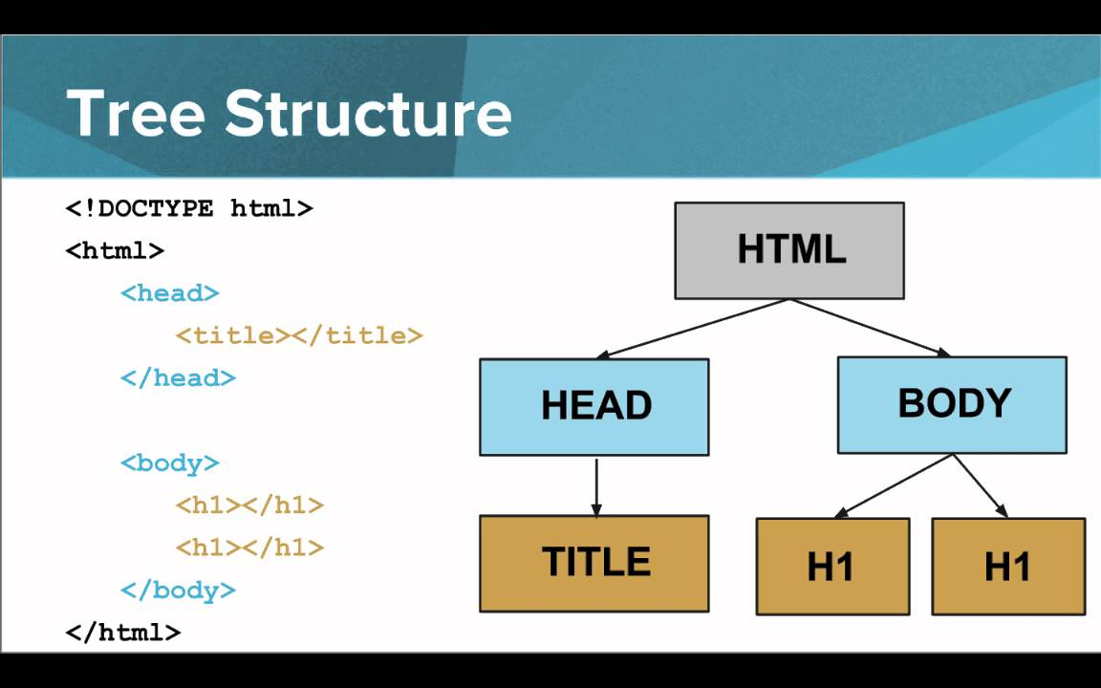

**Fig. 1 – HTML structure**

**HTML** : HTML stands for HyperText Markup Language. It is used to design web pages using a markup language. HTML is the combination of Hypertext and Markup language. Hypertext defines the link between web pages. A markup language is used to define the text document within the tag which defines the structure of web pages. This language is used to annotate (make notes for the computer) text so that a machine can understand it and manipulate text accordingly. Most markup languages (e.g. HTML) are human-readable. The language uses tags to define what manipulation has to be done on the text.

**CSS** : Cascading Style Sheets, fondly referred to as CSS, is a simply designed language intended to simplify the process of making web pages presentable. CSS allows you to apply styles to web pages. More importantly, CSS enables you to do this independent of the HTML that makes up each web page. It describes how a webpage should look: it prescribes colors, fonts, spacing, and much more. In short, you can make your website look however you want. CSS lets developers and designers define how it behaves, including how elements are positioned in the browser.While html uses tags, css uses rulesets. CSS is easy to learn and understand, but it provides powerful control over the presentation of an HTML document.

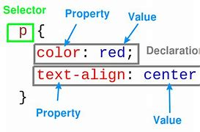

**Fig. 2 – CSS structure**

**3.3 Functionalities of JavaScript**

JavaScript is a lightweight, cross-platform, and interpreted compiled programming language which is also known as the scripting language for webpages. It is well-known for the development of web pages, many non-browser environments also use it. JavaScript can be used for Client-side developments as well as Server-side developments.

Javascript is both imperative and declarative type of language. JavaScript contains a standard library of objects, like Array, Date, and Math, and a core set of language elements like operators, control structures, and statements. JavaScript can be added to your HTML file in two ways:

a. **Internal JS**: We can add JavaScript directly to our HTML file by writing the code inside the <script> tag. The <script> tag can either be placed inside the <head> or <body> the tag according to the requirement.

b. **External JS**: We can write JavaScript code in other file having an extension.js and then link this file inside the <head> tag of the HTML file in which we want to add this code.

**Syntax :** <script>

// JavaScript Code

</script>

**Applications of JavaScript:**

• Web Development

• Web Applications

• Server Applications

• Games

• Smartwatches

• Machine Learning

• Mobile Applications

**3.4 Use of PHP**

The term PHP is an acronym for PHP: Hypertext Preprocessor. PHP is a server-side scripting language designed specifically for web development. It is open-source which means it is free to download and use. It is very simple to learn and use.

Syntax : <?php

PHP code goes here

?>

Advantages of PHP –

* Platform Independent
* Open source and dynamic Library support
* Free Availability
* Database:
* Easy to understand and code:
* Gives Web Developer More Control

**3.5 MySQL Database**

MySQL is an open-source Relational Database Management System that stores data in a structured format using rows and columns. To perform various operations users make requests by typing specific statements. The server responds to the information from the user and Displays it on the user side.

Characteristics of SQL :

• It allows the user to create, update, delete and retrieve data from a database.

• It is used specifically for relational databases.

• It works with database programs like DB2, Oracle, MS Access, etc.

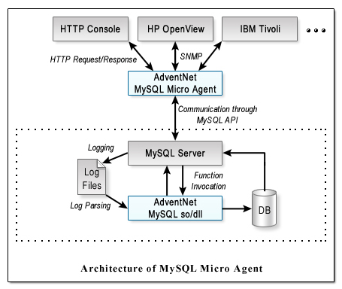

**Fig. 3 – Architecture of MySQL**

1. **Client Layer**: This layer is the topmost layer in the above diagram. The Client give request instructions to the Serve with the help of Client Layer .

2. **Server Layer**: The second layer of MYSQL architecture is responsible for all logical functionalities of relational database management system of MYSQL.

3. **Storage Layer**: This Storage Engine Layer of MYSQL Architecture make it’s unique and most preferable for developer’s . Due to this Layer MYSQL layer is counted as the mostly used RDBMS and is widely used.

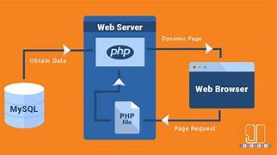

**Fig. 4 – Combined working of MySQL & PHP**

* PHP provides mysql_connect() function to open a database connection. This function takes a single parameter, which is a connection returned by the mysql_connect() function.
* You can disconnect from the MySQL database anytime using another PHP function mysql_close().

**XAAMP** : It helps a local host or server to test its website and clients via computers and laptops before releasing it to the main server. It is a platform that furnishes a suitable environment to test and verify the working of projects based on Apache, Perl, MySQL database, and PHP through the system of the host itself.

**RESERCH METHODOLOGY**

**4.1 The Waterfall Model**

The waterfall methodology is a linear project management approach, where stakeholder and customer requirements are gathered at the beginning of the project, and then a sequential project plan is created to accommodate those requirements.

The most important phases of the waterfall model can start functioning as follows:

* **Analysis**: This phase will be tasked with gathering all the information available on other online complaint portal and devising the different parameters that’ll be used for determining helpful website for the public .
* **Design**: In this example of the waterfall model, the design phase is all about fine-tuning the parameters established in the analysis phase and making sure that the structure of the software program is precise enough to avoid any manipulation of or confusion over large volumes of data.
* **Implementation**: This all-important phase involves doing dummy runs of the website program with a provisional set of data to see the accuracy with which the program can give the relevant question sets to students.
* **Testing**: As with any example of the waterfall model, the testing phase is about ensuring that all features of the software program function smoothly and that there are no glitches that can derail the utility of the overall program.
* **Maintenance**: In the final phase, the software program should be checked for any necessary updates or alterations that may be required, besides the expected inclusion of new data.

**4.2 Design Goals**

Our design goal can be summarized as follows:

* To optimizing the user experience.
* Using HTML, JavaScript and CSS to bring concepts to life.
* Developing and maintaining the user interface.
* Implementing design on websites.
* Managing software workflow.
* Fixing bugs and testing for usability.

**4.3 Step-wise methodology**

* Firstly we will analyse the software requirements.
* Making rough sketch of design of the website.
* Designing the frontend using HTML, CSS and JavaScript by refeering to the rough sketch.
* Trying to identify any errors and correcting it.
* Adding the functionality of login MySQL.
* Testing the system by performing all the possible operations.

**PROJECT DESIGN**

**5.1 Front End**:

* HTML (Hypertext Markup Language) is the standard markup language for creating web pages and web applications.
* It is used to define the structure and content of a web page, including the text, images, and other media.
* CSS (Cascading Style Sheets) is a stylesheet language used for describing the look and formatting of a document written in HTML. CSS is used to control the layout and design of a webpage, including the font, colour, and size of text, the placement of elements on the page, and the responsive design of the page for different screen sizes.
* JavaScript is a programming language that is commonly used in web development. It is used to add interactivity and dynamic behaviour to web pages, such as animations, form validation, and creating event-driven applications.
* jQuery is a JavaScript library that makes it easier to work with HTML, CSS, and JavaScript. It provides a number of useful functions and methods for manipulating the DOM (Document Object Model) and handling events, as well as for making AJAX requests.
* AJAX (Asynchronous JavaScript and XML) is a technique used for making requests to a server from a client-side web application, without the need to refresh the entire page. It allows web pages to be more interactive and responsive by updating only specific parts of the page based on the data received from the server. AJAX is often used with jQuery, which provides a number of functions and methods for making AJAX requests.

**5.2 Backend:**

Node.js is a server-side platform based on the JavaScript Engine in Google Chrome. It was created by Ryan Dahl in 2009, and the most recent version is v0.10.36. This is a cross-platform runtime environment for developing server-side and networking applications that are open source. Node.js programs are written in JavaScript and run on the Node.js runtime on OS X, Microsoft Windows, and Linux. Node.js also comes with a big library of JavaScript modules, which makes developing Node.js web applications much easier.

The Node is program runs in a single process rather than establishing a new thread for each request. Blocking behaviour is the exception rather than the rule in Node.js, because the standard library offers a set of asynchronous I/O primitives that prevent JavaScript code from blocking, and libraries in Node.js are frequently written using non-blocking paradigms. The popularity of Node.js is skyrocketing right now. Netflix, Uber, PayPal, Twitter, and more well-known companies are presently using Node.js. According to Stack Overflow's 2021 Developer Survey, Node.js is the 6th most popular technology among programmers, with nearly one-third of professional developers putting it as their first preference.

Node.js is sometimes misunderstood by developers as a backend framework that is exclusively used to construct servers. This is not the case; Node.js can be used on the frontend as well as the backend. The event-driven, non-blocking nature of Node.js frameworks is one of the reasons it is a popular choice for developers designing a flexible and scalable backend.

Some of the reasons why Node.js is suitable for both backend and frontend development are:

**• Reusability**

With the support of frameworks like Express.js and Meteor.js, JavaScript is a common language for writing both backend and frontend code.

Express.js is used as a backend in certain popular stacks, such as MERN (a Node.js framework). Between the frontend and the backend, multiple components can be reused.

• **Productivity and Developer Efficiency**

A significant amount of developer time can be saved by reducing context switching between several languages. Because many technologies are common for both backend and frontend, using JavaScript for both leads to enhanced efficiency.

**5.2.1 Node.js Frameworks:**

Some jobs are still difficult to accomplish with Node.js, so various frameworks have been created to help.

The following are some of the most popular Node.js frameworks:

• Nest.js - This is a powerful Node.js backend framework that is appropriate for constructing enterprise-level projects. It has a large number of libraries that implement Typescript, Model-View-Presenter (MVP), and integrated Object-Oriented-Programming (OOP), Function-Point (FP), and Functional-Reactive-Programming (FRP) principles (FRP).

• Express.js -is It a lightweight, minimally designed framework with a large set of HTTP helpers. It is used by developers who do not require a lengthy and costly development procedure. It's also ideal for creating APIs, mobile apps, and web applications. • Socket.io - Its user-friendliness makes it simple to utilise across a variety of platforms. It is primarily concerned with bi-directional real-time connectivity. Reconnection, binary, and multiplexing are also supported.

• Meteor.js - This enables real-time functionality, dynamic imports, front-end-back-end connectivity, and API protection.

• Koa.js - This uses asynchronous methods to make error handling easier and improve the performance of the application.

• Loopback.io - It enables developers to quickly create APIs by providing a number of features that make the process easier. Ad-hoc queries and storage services are supported. It supports a variety of REST services as well as a number of well-known databases.

**5.2.2 Express Framework:**

Express is a popular web framework for Node.js. It is a minimalist framework that provides a set of functions and middleware for building web applications and APIs.

Some key features of Express include:

• Routing: Express makes it easy to define and handle different routes (URL paths) in a web application.

• Middleware: Express allows developers to use middleware functions to perform tasks such as parsing request bodies, serving static files, and handling errors.

• Templates: Express supports the use of template engines such as EJS, Pug, and Handlebars, which allow developers to generate dynamic HTML pages based on data from the server. 18

• HTTP helpers: Express provides a number of functions for handling common HTTP tasks, such as redirecting requests, setting response headers, and sending responses.

• Together, Node.js and Express form a powerful combination for building modern web applications. They are widely used in the development of server-side JavaScript applications, and are a popular choice for building APIs and micro services.

**5.3 Block Diagram**

**Home page:**

The below flowchart shows the entire flow of how the user will interact with the platform. Firstly the homepage will be rendered to the user and if the use hits the submit a complaint button they will be redirected to the complaint form, where they can register a complaint. Once they fill out the form with all the necessary information a thank you page renders and they are redirected to the homepage again.

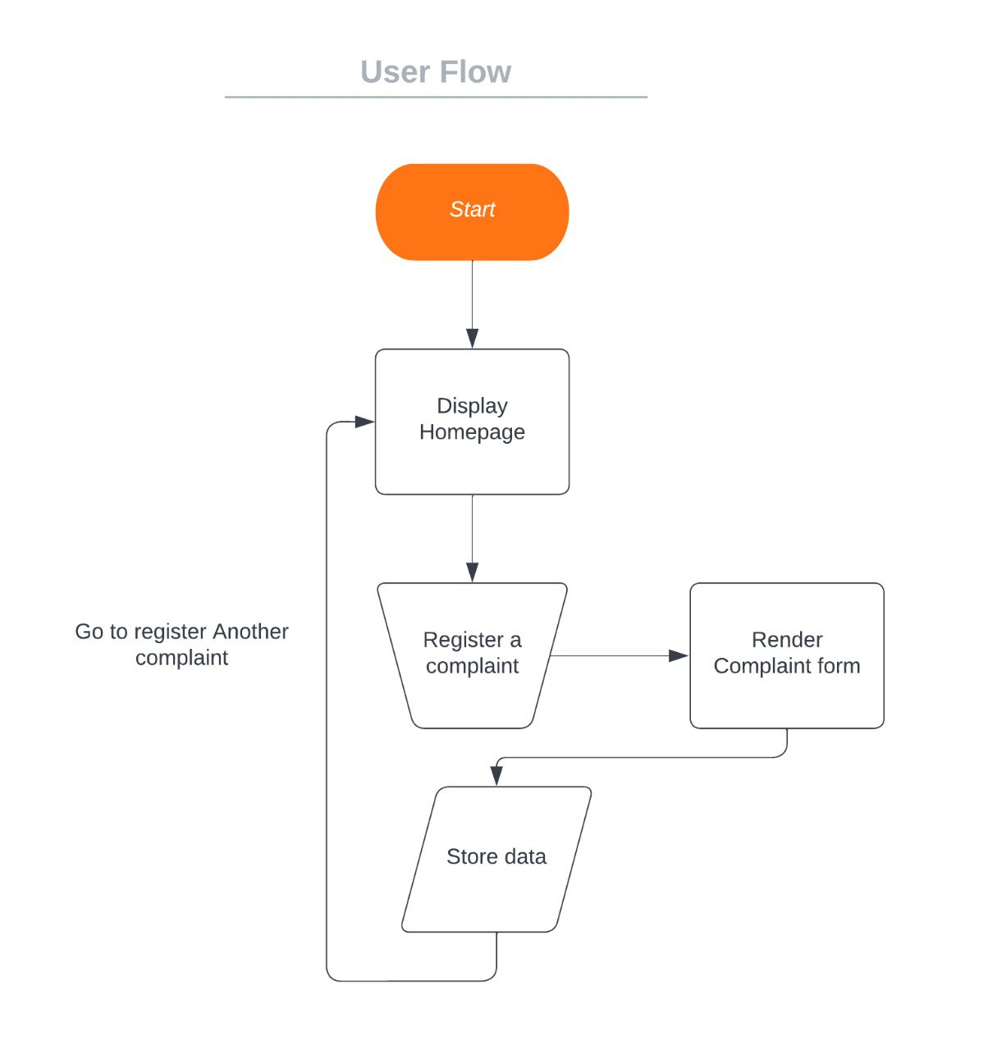

**Fig. 5 User flow chart**

**Admin page:**

The admin module of the website allows the complaints to be viewed and monitored by the platform admins. In order to access admin page the admin should have an admin account upon logging to their account the admin dashboard appears where the admin will be able to view all the complaint registered by the user so far.

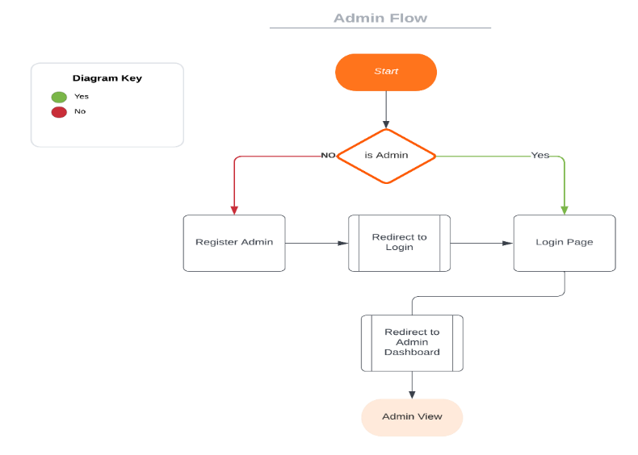

**Fig. 6 Admin Flow chart**

**Admin Use Case:**

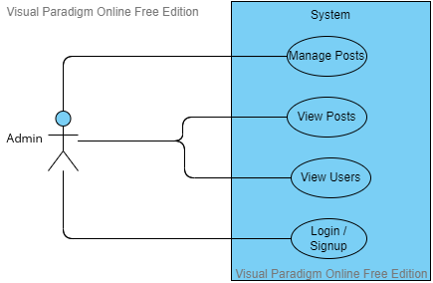

**Fig. 7 Admin use Case**

The admin also has certain use cases such as managing posts by performing certain operation such as deleting irrelevant and sensitive posts which doesn’t follow the platform ethics. Similar to a user the admin can also view the posts and along with this they can also view the users present on the platform. In order to access the admin privilege they must be registered as an Admin by the Super Admin.

**5.4 Project Code**

<!DOCTYPE html>

<html lang="en">

<head>

<meta charset="UTF-8">

<meta http-equiv="X-UA-Compatible" content="IE=edge">

<meta name="viewport" content="width=device-width, initial-scale=1.0">

<title>Document</title>

<link rel="stylesheet" href="style.css">

</head>

<body>

<div class="container">

<!-- Navbar Section -->

<div class="navbar">

<div class="orange-nav">

<span>Govt of India</span>

</div>

<div class="white-nav">

<img src="images/bharat-sarkar-logo.svg" alt="">

</div>

<div class="green-nav">

<span>RTO Complaint Portal</span>

</div>

</div>

<!-- Mid Section -->

<div class="present-section">

<div class="present-title">

<h1 class="text1">Here we make sure you get </h1>

<h1 class="text2">your voice heard.</h1>

<span>Our platform acts as a mediator where consumers and companies <br> can find a common language

together to solve their problem.</span>

<br><a class="submit-complaint-btm" href="registerComplaint.html">Submit Complaint</a>

</div>

<div class="present-image">

<img class="present-img" src="images/present-img.svg" alt="">

</div>

</div>

<!-- Reviews Section -->

<div class="background-caraousel">

<div class="slideshow-container">

<div class="mySlides fade">

<img src="images/r1.jpg" style="width:25%">

</div>

<div class="mySlides fade">

<img src="images/r2.jpg" style="width:25%">

<!-- <img src="img_snow_wide.jpg" style="width:100%"> -->

</div>

<div class="mySlides fade">

<img src="images/r3.jpg" style="width:25%">

<!-- <img src="img_mountains_wide.jpg" style="width:100%"> -->

</div>

<a class="prev" onclick="plusSlides(-1)">❮</a>

<a class="next" onclick="plusSlides(1)">❯</a>

</div>

</div>

<br>

<script>

**let** slideIndex = **1**;

showSlides(slideIndex);

**function** plusSlides(n) {

showSlides(slideIndex += n);

}

**function** currentSlide(n)

{

showSlides(slideIndex = n);

}

**function** showSlides(n)

{

**let** i;

**let** slides = document.getElementsByClassName("mySlides");

**let** dots = document.getElementsByClassName("dot");

**if** (n > slides.length) { slideIndex = **1** }

**if** (n < **1**) { slideIndex = slides.length }

**for** (i = **0**; i < slides.length; i++) {

slides[i].style.display = "none";

}

**for** (i = **0**; i < dots.length; i++) {

dots[i].className = dots[i].className.replace(" active", "");

}

slides[slideIndex - **1**].style.display = "block";

dots[slideIndex - **1**].className += " active";

}

</script>

</body>

</html>

**RESULT OF PROPOSED METHOD**

**6.1 Snapshot**

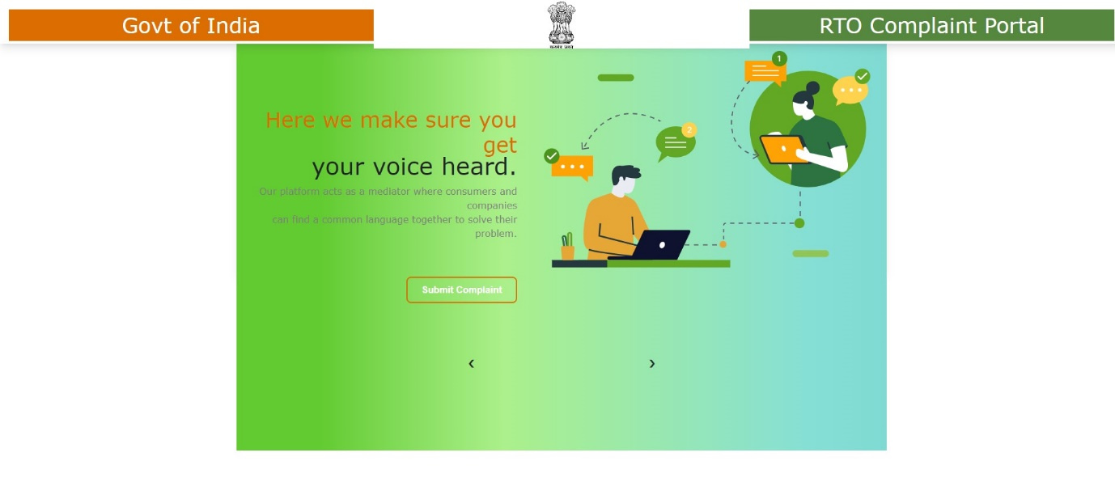

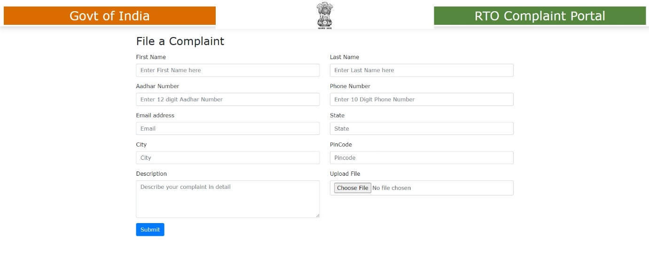

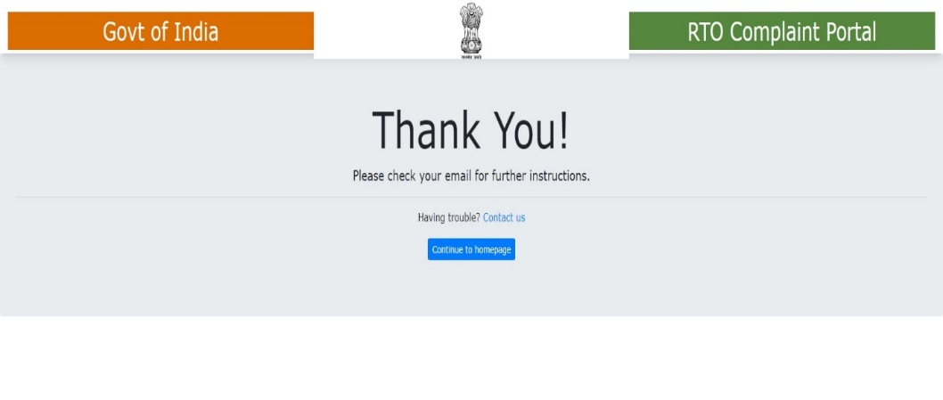

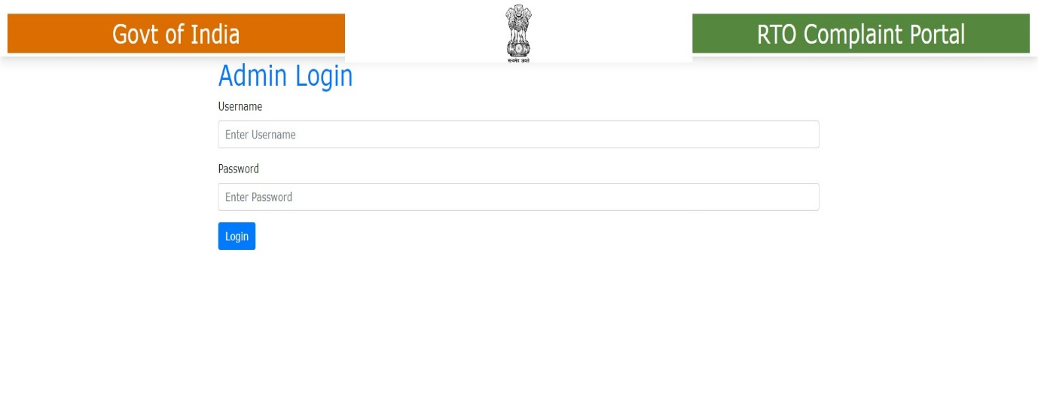

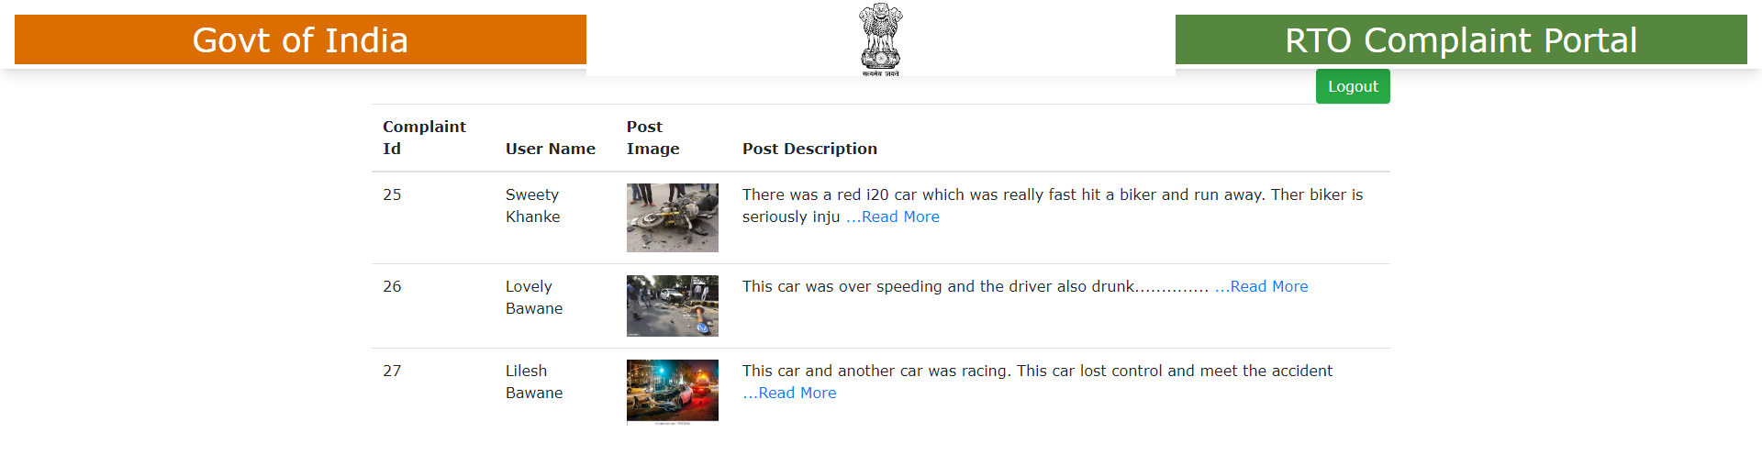

**HARDWARE AND SOFTWARE**

**Hardware Requirements (minimum)**

* 64/32 bit Operating System, x86 based processor
* Active Internet Connection
* Display Adapters

**Software Requirements +**

* Latest Browser Support
* JavaScript enabled browser
* Client/Server Side scripting enabled

**CONCLUSION & FUTURE SCOPE REQUIREMENTS**

**7.1 Conclusion**

* In this project we created an Online Complaint portal to interact with the citizens and help them out with their queries. We used some popular technologies which are essential to build a webpage which involves technologies such as HTML, CSS and Bootstrap.
* As per a survey, people find it difficult to visit offices if they want to file a complaint or so we have designed the project to provide the user with easy navigation, retrieval of data and necessary feedback as much as possible and it allows transparency to the user after filing a complaint about what actions are being taken in order to resolve the issue.

**7.2 Future Scope**

* We assume to integrate the project with some advanced web frameworks in order to improve the user experience.
* We have also planned to integrate AI system into this which will help the authorities to filter and take necessary actions by figuring out and learning from past data.
* This could be really helpful in various fields. The projects aims to be integrated with React/Angular web frameworks to develop a SPA (Single page application).

**REFERENCES**

* MDN Web Docs https://developer.mozilla.org/en-US/
* W3Schools https://www.w3schools.com/html/
* Butter Academy YT Channel https://www.youtube.com/ButterAcademy
* Fontawesome Web Icons <https://fontawesome.com/icon>
* <https://stackoverflow.com/questions/2353818/how-do-i-get-started-with-node-js>
* <https://github.com/calvinmetcalf/streams-a-love-story>
* <http://maxogden.com/node-streams.html>
* <https://github.com/substack/stream-handbook>
* [How streams help to raise Node.js performance](https://www.youtube.com/watch?v=QgEuZ52OZtU)
* <https://expressjs.com/en/guide/routing.html>
* <https://api.elephantsql.com>
* <https://expressjs.com/en/guide/database-integration.html#postgresql>